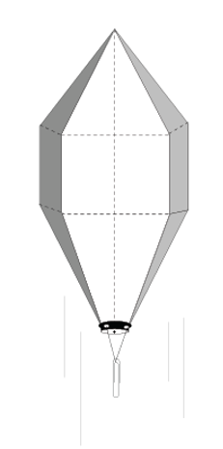

130 cm

A polyhedron is a solid form with flat polygonal faces, straight edges and sharp corners or vertices. The word **polyhedron** comes from the Greek root words *poly-* ( "many") + *-hedron* ("base"). Cubes and pyramids are examples of polyhedra.

A  **pentadecahedron** is a polyhedron with 15 faces.

**Balloon Name:____________________________________________________________________**

**Team Members: __________________________________________________________________**

**__________________________________________________________________**

**___________________________________________________________________**

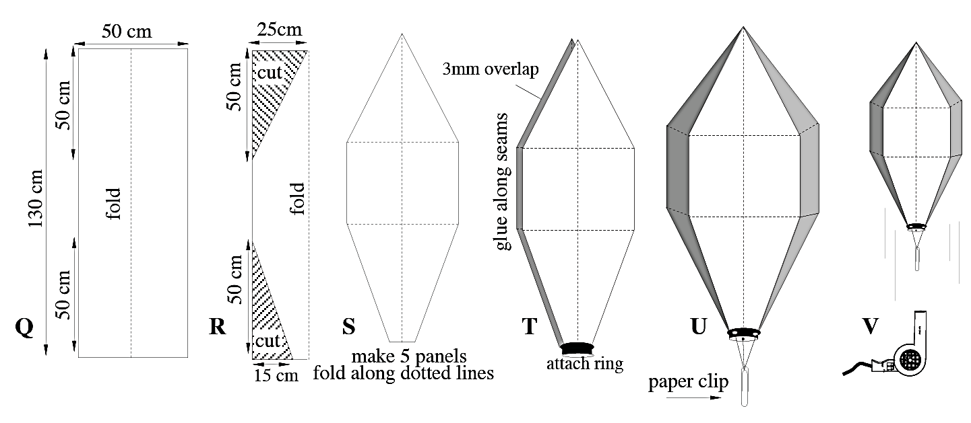

Materials:

* Colored Tissue:________________________________________________________________________________
* Cereal Box
* Paper Grocery bag

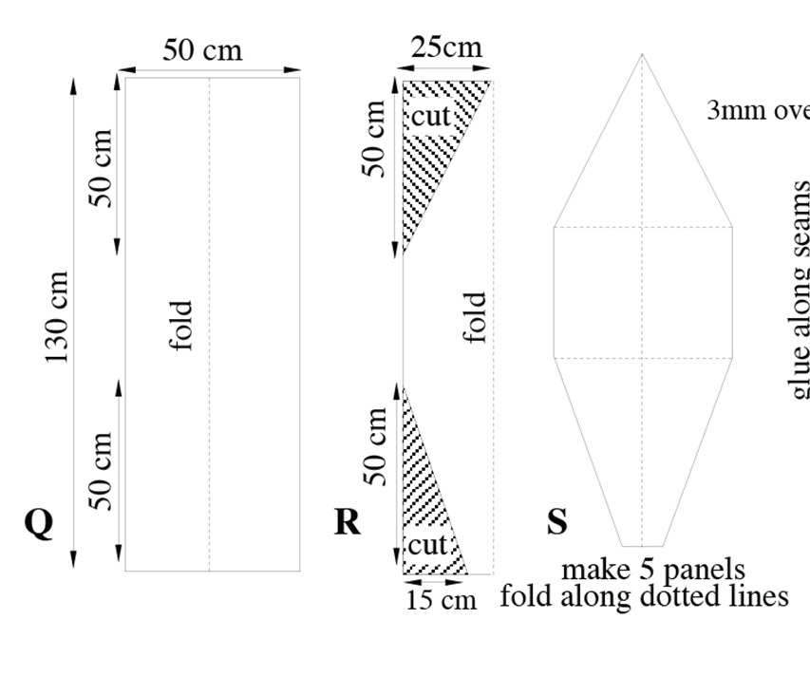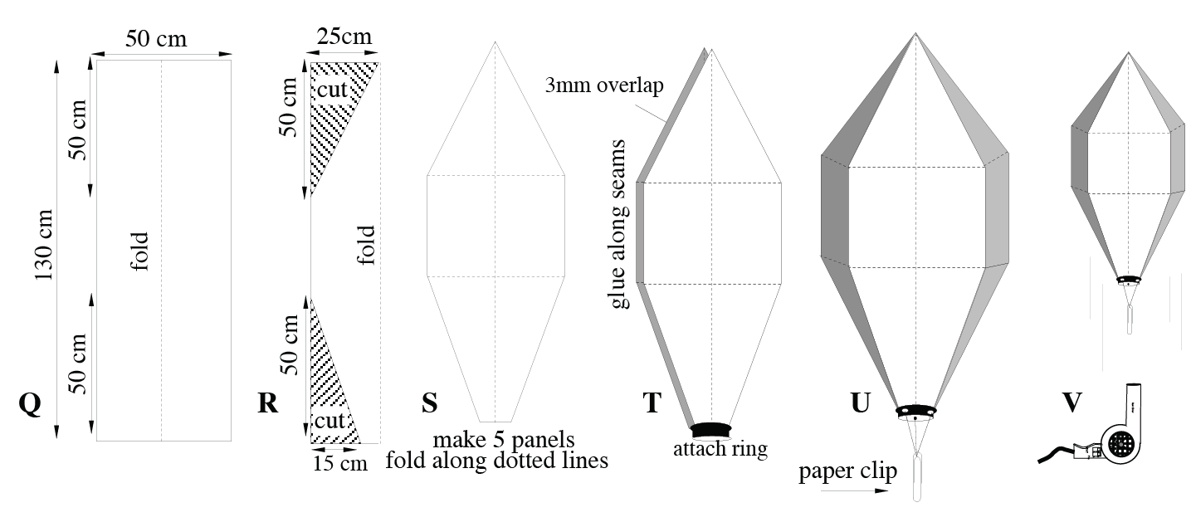

Top

Team Falcon  
Mary Jones  
Trudy Target

Bottom

Top

Team Falcon  
Mary Jones  
Trudy Target

Bottom

* Fold bottom of the paper to make a straight edge.
* Measure a Make a 130x50cm panel on butcher paper
* Label Top, Bottom, & team names.
* Measure up from the bottom and make a mark at 50cm.
* Measure down from the top and make a mark at 50 cm.
* Unfold your pattern.
* Check to make sure it is symmetrical.
* Fold your panel in half lengthwise.
* Mark the Bottom at 15cm from the cut edge.
* Mark the Top at 25cm from the cut edge.
* Using a ruler, draw a straight line to connect the Bottom points and Top points.
* Carefully cut out triangles at bottom and top (you may staple this area if it helps)

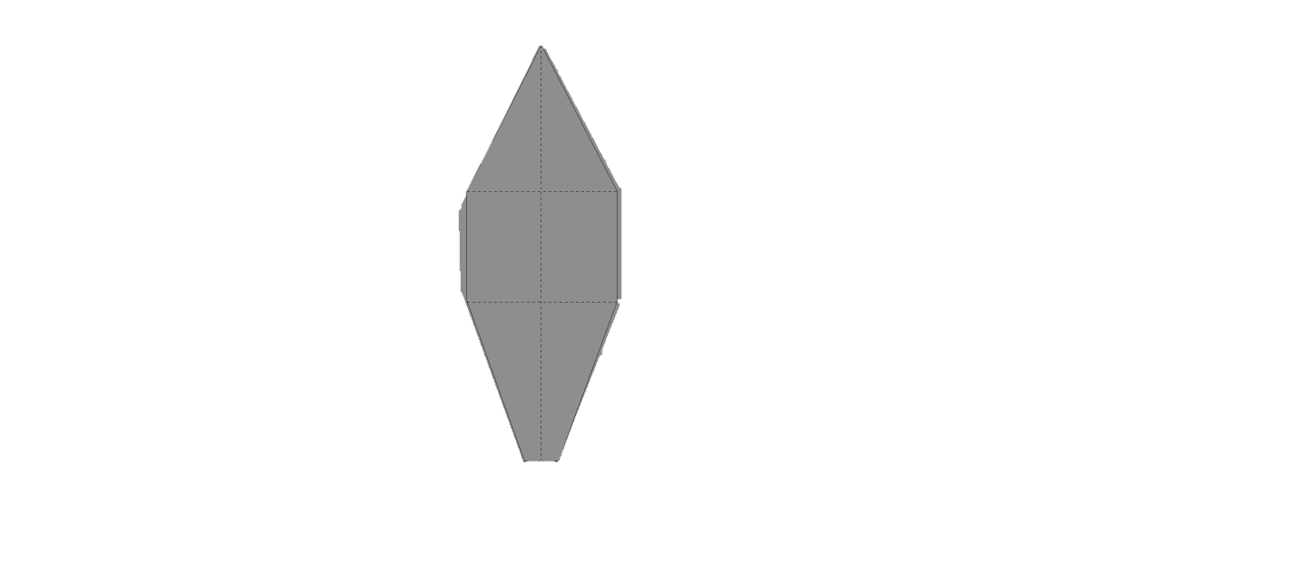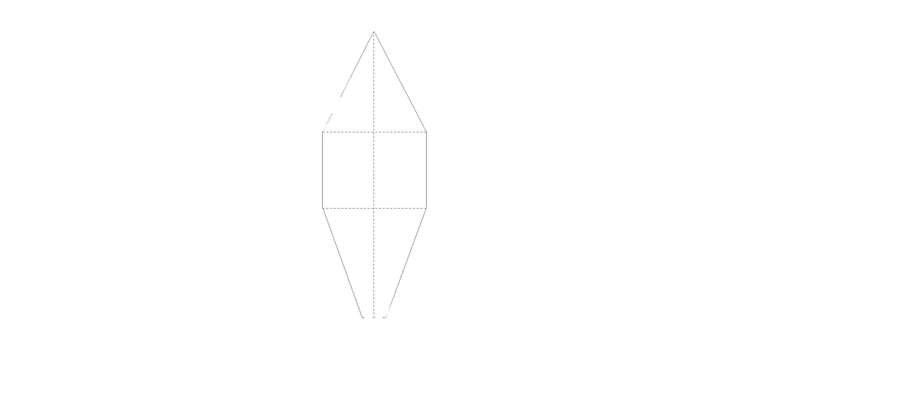

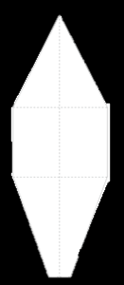



Top

Team Falcon  
Mary Jones  
Trudy Target

Bottom

Glued Seam

Glue along seam

Glue along seam

**Creating the gores…**

* Create five 55 x 140 cm panels of tissue paper to match your design.
* Panels should be wider than your pattern
* Stack your panels together and place your pattern on top.
* Have the teacher check your work, the carefully cut your gores.
* Lay the 5th panel on top of a glued pair.
* Glue the 5th panel to the top of the first pair on the **right** side. Carefully fold over when dry to reveal the next cut sides.
* Glue the bottom of the panel to the top of the next panel. Fold over when dry.
* Have the teacher check your work.
* Glue the final two cut edges together,

**Assemble the gores…**

* Place two panels on a table and adjust so that 3 cm of the bottom panel along the **left** side border is visible..
* Carefully apply glue to the top panel, then fold the border of the bottom panel onto the glue to seal the seam.
* Use 2 more panels to make another pair.

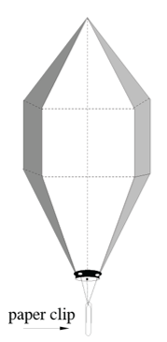



**Attach a ring…**

* Tie a loop of string around the top
* Glue a strip of construction paper around the base of the balloon.
* Punch three holes in this paper and suspend a small paper clip by threads as shown

**Questions**: 

* How long did your balloon stay aloft?
* Will your balloon rise faster on a cool day or a warm day? Explain.
* Why does the hot air balloon eventually fall back to earth?
* Why does the density of the air in the balloon decrease as it is heated?

**Check for holes:**

* Using the indoor balloon tester, check for holes in your balloon.
* Patch repairs,
* Store your balloon in a paper bag with your team’s name on it.