**Large Globe Balloon**

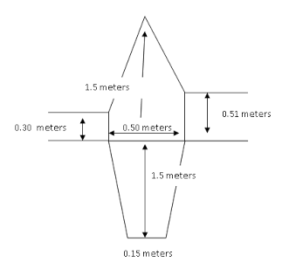

300 cm

**Balloon Name:____________________________________________________________________**

**Team Members: __________________________________________________________________**

**__________________________________________________________________**

**___________________________________________________________________**

**Design Your Balloon**

Materials:

* Colored Tissue:________________________________________________________________________________
* Cereal Box
* Paper Grocery bag

**Make Your Template**

50 cm

Top

Team Falcon  
Mary Jones  
Trudy Target

Bottom

300 cm

150 cm

150 cm

7.5 cm

7.5 cm

* Make a 300 x 50cm panel of butcher paper
* Make a guide line using the fold over technique as a base for your bottom and top edges. This will be your bottom
* Label Top, Bottom, & team names.
* Fold your panel in half lengthwise, then mark using a meter stick. This will be your center line
* From the bottom dot, measure 150 cm up the center line and make a dot.
* Connect these dots by drawing a straight line with your meter stick
* Mark a dot where the center line and bottom line meet.
* From the bottom dot, measure 7.5 cm on each side of the bottom line and mark.

**Make Your Template**

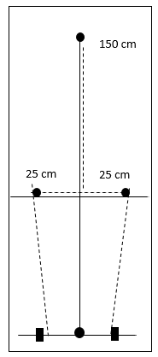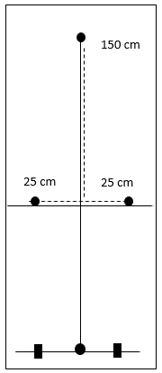

150 cm

51 cm

30 cm

25 cm

25 cm

* From the center dot, measure and mark 25 cm on each side.
* From the center dot, Measure up 150 cm and mark with a dot.
* **Right Side:** From the center dot, measure 51 cm up and make a dot. Now measure 25 cm to the center line to make sure your line is straight. Connect with a line
* **Left Side:** From the center dot, measure 30 cm up and make a dot. Now measure 25 cm to the center line to make sure your line is straight. Connect with a line.
* Connect your Right and Left side lines to the top. Have the teacher check before cutting out template.
* Connect the dots from the bottom corner to the center dot on the right and left sides.

**Ready Your Panels**

Top

Team Falcon  
Mary Jones  
Trudy Target

Bottom

* Make 10 panels by gluing squares of tissue paper together with a 1/2 inch overlap.
* By alternating the colors of the squares a checkered design can be achieved.
* Stack the panels neatly on top of each other
* Lay the template on top
* Have the teacher check your work
* Cut out gores carefully.

**Finished Template**

Top

Team Falcon  
Mary Jones  
Trudy Target

Bottom

**Assemble the Gores**

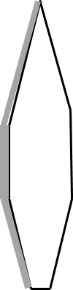

3rd Pair

2nd Pair

Image result for glue stickblack & white

**Image result for glue stickblack & white**Image result for glue stickblack & white****



* Stack the 5 pairs on top of each other.
* Fold over the top gore (#1).
* Glue gore #2 to gore #3, fold over.
* Glue gore #4 to gore #5, fold over.
* Glue gore #6 to gore #7, fold over.
* Glue gore #8 to gore #9, fold over.
* Place two panels on a table and adjust so that 3 cm of the bottom panel along the **Left** side border is visible.
* Carefully apply glue to the top panel, then fold the border of the bottom panel onto the glue to seal the seam.
* Make 4 more pairs.
* Have the teacher check your work.
* Glue gore #1 to gore #10

#5

#3

Gore #2

#4

Fold over Gore #1

4th Pair

5th Pair

1st Pair

**Finishing & Quality Control**

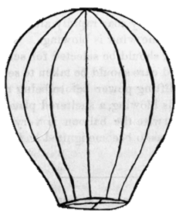

**Attach a ring…**

* Glue a strip of construction paper around the base of the balloon.
* Attach a string with loop to the top of the balloon,

**Questions**: 

* How long did your balloon stay aloft?
* Will your balloon rise faster on a cool day or a warm day? Explain.
* Why does the hot air balloon eventually fall back to earth?
* Why does the density of the air in the balloon decrease as it is heated?

**Check for holes:**

* Using the indoor balloon tester, check for holes in your balloon.
* Patch repairs,
* Store your balloon in a paper bag with your team’s name on it.