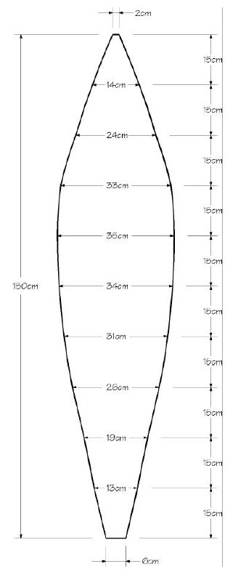

18cm

17 cm

25 cm

40 cm

34 cm

44 cm

46 cm

43 cm

32 cm

8 cm

3 cm

20 cm

20 cm

20 cm

20 cm

20 cm

20 cm

20 cm

20 cm

20 cm

20 cm

200 cm

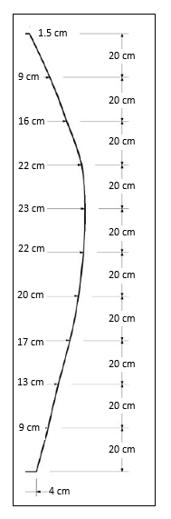

Fold

**Balloon Name:____________________________________________________________________**

**Team Members: __________________________________________________________________**

**__________________________________________________________________**

**___________________________________________________________________**

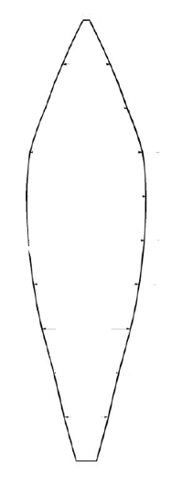

Materials:

* Colored Tissue:________________________________________________________________________________
* Cereal Box
* Paper Grocery bag

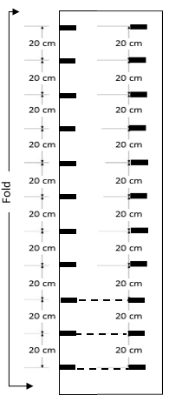

50 cm

Top

Team Falcon  
Mary Jones  
Trudy Target

Bottom

250 cm

**Measuring Carefully…**

* Make a 250x50cm panel (butcher paper)
* Make a guide line using the fold over technique as a base for your bottom and top edges.
* Label Top, Bottom, & team names.
* Unfold your pattern.
* Check to make sure it is symmetrical.
* Fold your panel in half lengthwise.
* On the folded edge, make a mark every 20 cm’s. You will need 11 marks.
* Measure up from your bottom guide line and make 11 marks near the cut edge of your pattern. Connect the lines
* Beginning at the bottom, measure perpendicular from the fold at each line, marking 4cm, then 9cm, 13 cm, 17cm, until you reach the top.
* Connect all of the outside marks
* Cut out your pattern

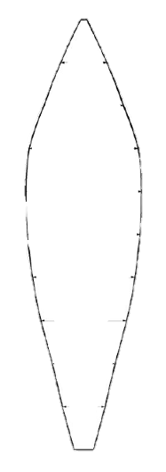



Top

Team Falcon  
Mary Jones  
Trudy Target

Bottom

Glue along right side

Glued Seam

**Creating the gores…**

* Create **seven** 50 x 130 cm panels of tissue paper to match your design.
* Panels should be wider than your pattern
* Stack your panels together and place your pattern on top.
* Have the teacher check your work, the carefully cut your gores.
* Lay the 7th panel on top of a glued pair.
* Glue the 7th panel to the top of the first pair on the right side. Carefully fold over when dry to reveal the next cut sides.
* Glue the bottom of the panel to the top of the next panel. Fold over when dry.
* Have the teacher check your work.
* Glue the final two cut edges together,

**Assemble the gores…**

* Place two panels on a table and adjust so that 3 cm of the bottom panel along the left side border is visible..
* Carefully apply glue to the top panel, then fold the border of the bottom panel onto the glue to seal the seam.
* Make 2 more pairs, you will have 1 panel left.

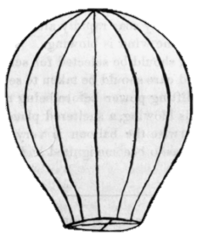



**Attach a ring…**

* Tie a loop of string around the top
* Glue a strip of construction paper around the base of the balloon.
* Punch three holes in this paper and suspend a small paper clip by threads as shown

**Questions**: 

* How long did your balloon stay aloft?
* Will your balloon rise faster on a cool day or a warm day? Explain.
* Why does the hot air balloon eventually fall back to earth?
* Why does the density of the air in the balloon decrease as it is heated?

**Check for holes:**

* Using the indoor balloon tester, check for holes in your balloon.
* Patch repairs,
* Store your balloon in a paper bag with your team’s name on it.